Sterling Energy Storage System Video – Social Media Toolkit

***This video is embargoed until Tuesday, September 12***

Video link: http://bit.ly/CEG-Sterling

(This bitly redirects to: http://www.cleanegroup.org/ceg-projects/resilient-power-project/featured-installations/sterling/)

We have created some sample social media posts that you can use to share Sterling’s energy storage success story. Use these or create your own! You can also engage with our posts by liking, commenting & sharing.

For additional photos, visit this album on our flickr account: https://www.flickr.com/photos/cleanenergygroup/sets/72157684018902160

If you have any questions, contact Clean Energy Group’s Communications Coordinator: Samantha@cleanegroup.org.

Twitter

Handles: @CESA_News, @CleanEnergyGrp
Tags: #SterlingMA, #energystorage, #solarstorage, #resilientpower, #batterystorage, #actonclimate, #climatechange, #cleanenergy, #greencommunities, #cleanenergyma

Sample Posts**:

“It’s absolutely phenomenal to think we are saving $400,000 a year." http://bit.ly/CEG-Sterling #solarstorage #energystorage #sterlingma

When the next big storm strikes, the little town of #SterlingMA is ready. Learn how: http://bit.ly/CEG-Sterling #energystorage #resilientpower

Video: Learn how a municipal utility is using energy storage to its save ratepayers money and ensure resilient power http://bit.ly/CEG-Sterling

Solar + battery storage could save your community $$. Learn how #solarstorage works in @CleanEnergyGrp’s new video: http://bit.ly/CEG-Sterling

Sterling’s #batterystorage system keeps the power on when natural disasters strike. http://bit.ly/CEG-Sterling via @CleanEnergyGrp

Learn how #solar and #energystorage is saving one Massachusetts town $400k/year: http://bit.ly/CEG-Sterling via @CleanEnergyGrp

**include images like these to indicate that it’s a video:

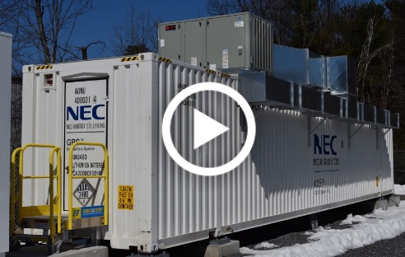

GIFs:

Sterling Aerial: https://gifs.com/gif/sterling-aerial-solar-vgX8Vr
Beautiful Solar Aerial: https://gifs.com/gif/updated-beautiful-aerial-solar-zm27Mr
Sterling Savings: https://gifs.com/gif/sterling-savings-gif-lOK2r6

Facebook

You can share the video directly from our Facebook page: www.facebook.com/Clean.Energy.Group
If you mention Clean Energy Group in your post, please tag our page!

Sample Posts:

“It’s absolutely phenomenal to think we are saving $400,000 a year,” says Irene Camerano in a new video from Clean Energy Group. She’s a customer of Sterling Municipal Light Department in Massachusetts, where a new solar+storage system is saving money for the utility and its customers while also providing up to 12 days of backup power to the police station to keep first responder operations running, even during extended power outages. https://youtu.be/w3It2lwLCm4

“If another ice storm or Sandy were to happen, I think large agencies would not be as prepared as the little town of Sterling is,” says Sterling, MA Police Chief Gary Chamberlin. The Sterling Municipal Light Department (SMLD) is keeping its ratepayers safer and saving them money with a new solar+storage microgrid. “We don’t know when the next Super Storm Sandy is coming, or the next ice storm, but we know now we’re prepared," said SMLD Manager Sean Hamilton in Clean Energy Group’s new video about this exciting project. Watch it here: https://youtu.be/w3It2lwLCm4

Other Key Resources

Full video on YouTube: https://youtu.be/w3It2lwLCm4

Video of animation segment only: https://youtu.be/8tB6UJK_l2g

Clean Energy Group press release, 9/12: http://www.cleanegroup.org/wp-content/uploads/Sterling-Video-PR.pdf

